**Classification – Grid Search CV Documentation**

1.) Identify your problem statement

Classification

2.) Tell basic info about the dataset (Total number of rows, columns)?

399 rows and 25 columns

3.) Mention the pre-processing method if you’re doing any (like converting string to number – nominal data)

I have used **One Hot Encoding,** pre-processing method toConvert string to number(nominal data)

**Pc , pcc, ba, htn, dm, cad, appet, pe, ane, classification,** these columns are changed by using this Pre-Processing method

**Documentation Of Machine Learning Classification Algorithm:**

**Bernoulli Naïve Bayes:**

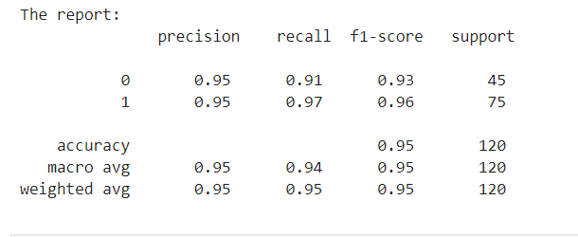

**roc_auc_score :**



**Categorical Naïve Bayes:**

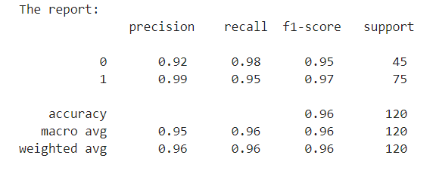

**roc_auc_score :**



**Complement Naïve Bayes:**

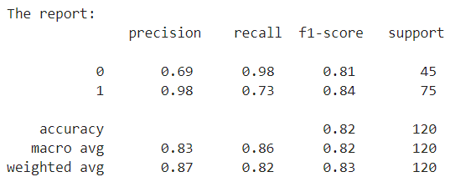

**roc_auc_score :**



**Decision Tree :**

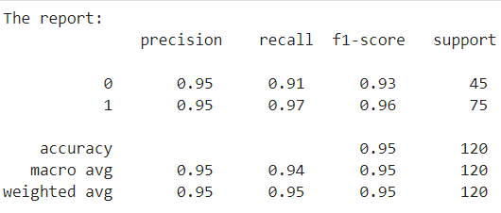

**roc_auc_score :**



**Gaussian Naïve Bayes:**

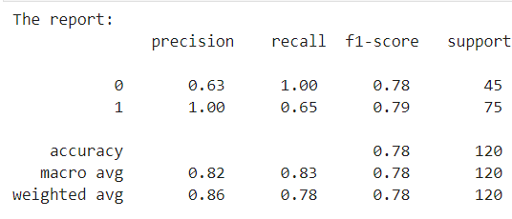

**roc_auc_score :**



**K Nearest Neighbors :**

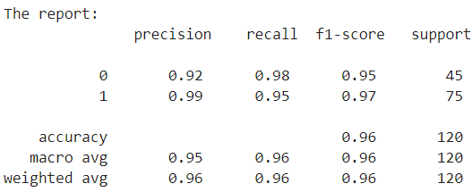

**roc_auc_score :**



**Logistic Regression :**

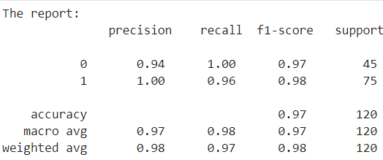

**roc_auc_score :**



**Multinomial Navie Bayes:**

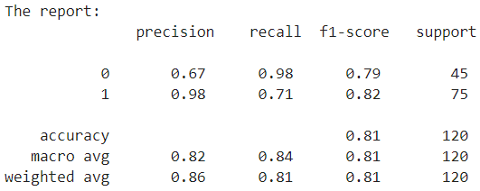

**roc_auc_score :**



**Random Forest :**

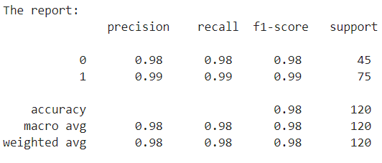

**roc_auc_score :**



**Support Vector Machine:**

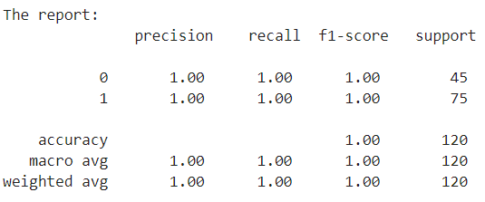

**roc_auc_score :**



**Support Vector Machine Classification is the final model I Choose .**

**Because It has Higher Accuracy when Compared to the Other Models.**